# 1.0 Use Case Modelling

The first iteration of the Use Case model is a simple diagram with only one or at most two use cases and a use case description for each

It can cover the complete system functionality in summary form

System Name

(Automated Sales System)

Actor

(Student)

## 1.1 Use Case Description

The use case description is developed from analysing the description of the use case. This is the statement of the goal of the use case.

For the first iteration this will be a description of the how the system operates.

Use Cases focus on functional requirements and specific system behaviour.

|  |  |  |  |  |
| --- | --- | --- | --- | --- |
| **USE CASE** | | 1. | Try on clothes with mobile app | |
| **Description of Goal in Context** | | The user will be able to use smartphone to visualize how some clothing would fit and look like. | | |
| **Preconditions** | | The user owns a smartphone (with a camera) and has downloaded the app.  Database already includes clothing items. | | |
| **Post Conditions, Success End Condition** | | The user can view oneself fitted with new clothing. | | |
| **DESCRIPTION** | | The user uses smartphone to take a video of a himself/herself or some other person. Data is sent to servers and then sent back fitted with different clothing. The user can now view himself/herself from smartphone screen with new clothing. | | |
| **Main Flow** | | | | |
| **Step** | **Action** | | | **Alternate** |
| n.1.1 | User downloads the app and opens it. | | |  |
| n.1.2 | System creates connection between phone and servers. | | |  |
| n.1.3 | System offers different clothes to try on. | | |  |
| n.1.4 | System opens camera’s video feed and sends data to servers. | | |  |
| n.1.5 | System calculates target size and position and fits clothes on top of the targe. | | |  |
| n.1.6 | System sends modified data to user’s phone. | | |  |
| n.1.7 | System offers option to select new piece of cloth or to quit the app. | | |  |
| n.1.8 | End use case. | | |  |
|  | | | | |
| **EXCEPTIONS or ERROR Flow Description** | | | | |
| **Step** | **Branching Action**  < Exception number m of Use Case n> | | | **Alternate** |
| 1.2.1 | **User has no internet connection**  System tries to make the connection between phone and servers. Limited to 5 reconnection attempts. | | |  |
| 1.2.2 | Connection made: go to MF 1.3.  Connection failed: Exit the app with user message to check connection and start the app again. END USE CASE. | | |  |
| 1.4.1 | **System doesn’t have permission to use end device’s camera**  System demands the permission. | | |  |
| 1.4.2 | Permission not granted: Urge the user to give permission in the settings. Otherwise exit the app. END USE CASE.  Permission granted: Go to MF 1.4 | | |  |
|  | | | | |
| **ALTERNATIVE or VARIATION Flow Description** | | | | |
| **Step** | **Branching Action** | | | **Alternate** |
| n.m.1 | <condition causing alternative>  <list of variation>  <Action, steps of scenario to goal delivery> | | |  |
| n.m.2 | <Action, steps of scenario to goal delivery> | | |  |

Non-functional requirements, management issues and decisions required to be made, can be identified in the following table

|  |  |  |
| --- | --- | --- |
| **RELATED INFORMATION** | Use Case: <number> | <Use case name> |
| **Priority:** | <how critical to your system/organization> | |
| **Performance** | <the amount of time this use case should take> | |
| **Frequency** | <how often it is expected to happen> | |
| **Channels to actors** | <e.g. interactive, static files, database, timeouts> | |
| **OPEN ISSUES** | <list of issues awaiting decision affecting this use case> | |
| **Due Date** | <date or release needed> | |

## Iteration 2

From the main flow of iteration 1 a number of use cases can be identified

These form the basis for the functional specifications of the system.

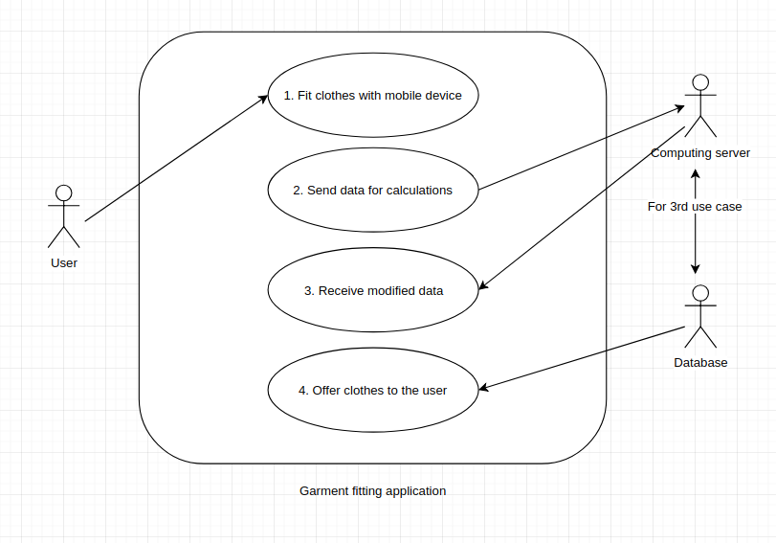

|  |  |  |  |  |
| --- | --- | --- | --- | --- |
| **USE CASE** | | 1. | Fit clothes with mobile device | |
| **Description of Goal in Context** | | The user will be able to use smartphone to visualize how some clothing would fit and look like. | | |
| **Preconditions** | | The user owns a smartphone (with a camera) and has downloaded the app.  Database already includes clothing items. | | |
| **Post Conditions, Success End Condition** | | The user can view oneself fitted with new clothing. | | |
| **DESCRIPTION** | | The user uses smartphone to take a video of a himself/herself or some other person. The user can view himself/herself from smartphone screen with new clothing. | | |
| **Main Flow** | | | | |
| **Step** | **Action** | | | **Alternate** |
| n.1.1 | User downloads the app and opens it. | | |  |
| n.1.2 | User chooses garment he/she wishesh to try on. | | |  |
| n.1.3 | User can view himself/herself with new garment. | | |  |
| n.1.4 | End use case. | | |  |
|  | | | | |
| **EXCEPTIONS or ERROR Flow Description** | | | | |
| **Step** | **Branching Action**  < Exception number m of Use Case n> | | | **Alternate** |
| 1.2.1 | **User has no internet connection**  System tries to make the connection between phone and servers. Limited to 5 re-connection attempts. | | |  |
| 1.2.2 | Connection made: go to MF 1.3.  Connection failed: Exit the app with user message to check connection and start the app again. END USE CASE. | | |  |
| 1.4.1 | **System doesn’t have permission to use end device’s camera**  System demands the permission. | | |  |
| 1.4.2 | Permission not granted: Urge the user to give permission in the settings. Otherwise exit the app. END USE CASE.  Permission granted: Go to MF 1.4 | | |  |

|  |  |  |  |  |
| --- | --- | --- | --- | --- |
| **USE CASE** | | 2. | Send data for calculations | |
| **Description of Goal in Context** | | User’s device sends video (data) to computing server for processing. | | |
| **Preconditions** | | The user has the app up and running and has granted the app the permission to use camera. Also connection to the servers have been made. | | |
| **Post Conditions, Success End Condition** | | The computing server receives valid data. | | |
| **DESCRIPTION** | | The user uses smartphone to take a video of a himself/herself or some other person. Data is sent to servers and chekced for validity. | | |
| **Main Flow** | | | | |
| **Step** | **Action** | | | **Alternate** |
| n.1.1 | System verifies the connection between user and servers is working. | | |  |
| n.1.2 | Mobile device sends data (video) to the computing server. | | |  |
| n.1.3 | System verifies that the data is valid. | | |  |
| n.1.4 | End use case. | | |  |
|  | | | | |
| **EXCEPTIONS or ERROR Flow Description** | | | | |
| **Step** | **Branching Action**  < Exception number m of Use Case n> | | | **Alternate** |
| 1.2.1 | **User has no internet connection**  System tries to make the connection between phone and servers. Limited to 5 re-connection attempts. | | |  |
| 1.2.2 | Connection made: go to MF 1.3.  Connection failed: Exit the app with user message to check connection and start the app again. END USE CASE. | | |  |
| 1.4.1 | **System doesn’t have permission to use end device’s camera**  System demands the permission. | | |  |
| 1.4.2 | Permission not granted: Urge the user to give permission in the settings. Otherwise exit the app. END USE CASE.  Permission granted: Go to MF 1.4 | | |  |

|  |  |  |  |  |
| --- | --- | --- | --- | --- |
| **USE CASE** | | 3. | Receive modified data | |
| **Description of Goal in Context** | | The user will be able to use smartphone to visualize how some clothing would fit and look like. | | |
| **Preconditions** | | The user owns a smartphone (with a camera) and has downloaded the app.  Database already includes clothing items. | | |
| **Post Conditions, Success End Condition** | | The user can view oneself fitted with new clothing. | | |
| **DESCRIPTION** | | The user uses smartphone to take a video of a himself/herself or some other person. Data is sent to servers and then sent back fitted with different clothing. The user can now view himself/herself from smartphone screen with new clothing. | | |
| **Main Flow** | | | | |
| **Step** | **Action** | | | **Alternate** |
| n.1.1 | User downloads the app and opens it. | | |  |
| n.1.2 | System creates connection between phone and servers. | | |  |
| n.1.3 | System offers different clothes to try on. | | |  |
| n.1.4 | System opens camera’s video feed and sends data to servers. | | |  |
| n.1.5 | System calculates target size and position and fits clothes on top of the target. | | |  |
| n.1.6 | System sends modified data to user’s phone. | | |  |
| n.1.7 | System offers option to select new piece of cloth or to quit the app. | | |  |
| n.1.8 | End use case. | | |  |
|  | | | | |
| **EXCEPTIONS or ERROR Flow Description** | | | | |
| **Step** | **Branching Action**  < Exception number m of Use Case n> | | | **Alternate** |
| 1.2.1 | **User has no internet connection**  System tries to make the connection between phone and servers. Limited to 5 re-connection attempts. | | |  |
| 1.2.2 | Connection made: go to MF 1.3.  Connection failed: Exit the app with user message to check connection and start the app again. END USE CASE. | | |  |
| 1.4.1 | **System doesn’t have permission to use end device’s camera**  System demands the permission. | | |  |
| 1.4.2 | Permission not granted: Urge the user to give permission in the settings. Otherwise exit the app. END USE CASE.  Permission granted: Go to MF 1.4 | | |  |

|  |  |  |  |  |
| --- | --- | --- | --- | --- |
| **USE CASE** | | 4. | Offer clothes to the user | |
| **Description of Goal in Context** | | The user will be able to use smartphone to visualize how some clothing would fit and look like. | | |
| **Preconditions** | | The user owns a smartphone (with a camera) and has downloaded the app.  Database already includes clothing items. | | |
| **Post Conditions, Success End Condition** | | The user can view oneself fitted with new clothing. | | |
| **DESCRIPTION** | | The user uses smartphone to take a video of a himself/herself or some other person. Data is sent to servers and then sent back fitted with different clothing. The user can now view himself/herself from smartphone screen with new clothing. | | |
| **Main Flow** | | | | |
| **Step** | **Action** | | | **Alternate** |
| n.1.1 | User downloads the app and opens it. | | |  |
| n.1.2 | System creates connection between phone and servers. | | |  |
| n.1.3 | System offers different clothes to try on. | | |  |
| n.1.4 | System opens camera’s video feed and sends data to servers. | | |  |
| n.1.5 | System calculates target size and position and fits clothes on top of the target. | | |  |
| n.1.6 | System sends modified data to user’s phone. | | |  |
| n.1.7 | System offers option to select new piece of cloth or to quit the app. | | |  |
| n.1.8 | End use case. | | |  |
|  | | | | |
| **EXCEPTIONS or ERROR Flow Description** | | | | |
| **Step** | **Branching Action**  < Exception number m of Use Case n> | | | **Alternate** |
| 1.2.1 | **User has no internet connection**  System tries to make the connection between phone and servers. Limited to 5 re-connection attempts. | | |  |
| 1.2.2 | Connection made: go to MF 1.3.  Connection failed: Exit the app with user message to check connection and start the app again. END USE CASE. | | |  |
| 1.4.1 | **System doesn’t have permission to use end device’s camera**  System demands the permission. | | |  |
| 1.4.2 | Permission not granted: Urge the user to give permission in the settings. Otherwise exit the app. END USE CASE.  Permission granted: Go to MF 1.4 | | |  |